CSET485 – AI and Society: Assignment #1 (10 Marks)
Algorithmic Stress-Testing, Hidden Confounds & Fairness Trade-Offs in Credit Underwriting
Enrollment ID: s24bcau0154 | Assigned Dataset: German Credit Data (Statlog) | Seed: 154 (Last 3 digits)
Partition: 70% Train (700) / 30% Test (300) | Target: Approval (1=Approve, 0=Reject) | Reproducibility: Full Jupyter Notebook
Objective: High-stakes predictive algorithms in credit lending often look statistically robust, but hide demographic bias, large omitted variable bias, and unavoidable fairness trade-offs. The German Credit dataset (N=1,000) is used in this report to evaluate robustness of Linear OLS and Logistic Regression under conditions of: threshold mismatch, Simpson's Paradox, omitted variable bias, adversarial failure clusters, and parametric fairness frontiers. All of our conclusions are backed by the numbers we calculated.
Data Preprocessing & Exploratory Audit
(1) No Missing Values. Confirmed zero (0) missing values for all 1,000 samples and 20 features. (per docs).

(2) Categorical. One Hot Encoded 13 qualitative features (drop_first=True, i.e., first category dropped to avoid multi-collinearity/dummy var traps) -- 41 indicator cols + 7 continuous regressors (total modeled predictors=48).

(3) Scaled features. Standardized 7 continuous features (duration, credit_amount, installment_commitment, residence_since, age, existing_credits, num_dependents) via StandardScaler, fit only on 70% training data (N=700, seed=154) to avoid leakage.

(4) Outlier reasoning. Retained 70 (7.0%) outliers in duration, 72 (7.2%) in credit_amount, 23 (2.3%) in age (per 1.5 x IQR). On purpose, retained without clipping. There are real tail risks in high balance/maturities. Default liabilities that we need the U/W models to learn.
Part 1 — Model Fitting & Threshold Mismatch Analysis
Two different models were trained with the same matrix of 700 samples (train approval base rate = 69.71%; test approval base rate = 70.67%).
Model A: Linear (OLS) Regression. Continuous (Y_hat) predictions on the test set vary between -0.0211 and 1.3459. The empirical median of Y_hat on the test set is 0.7151. Forcing a threshold to be the median value (Y_hat >= 0.7151) results in an exact number of 150 (50.0%) positive instances.
Model B: Logistic Regression. The sigmoidal probabilities (P_hat) vary between [0.0628, 0.9946]. The standard (P_hat >= 0.50) thresholding leads to the number of 240 (80.0%) positive instances. The test accuracy is: Model B = 75.33%, Model A = 68.00%.
Classification Alignment | Model A Negative (< Median) | Model A Positive (>= Median 0.7151) | Total Model B
Model B Negative (< 0.50) | 60 (True Agreement) | 0 | 60 (20.0%)
Model B Positive (>= 0.50) | 90 (Mismatched: 30.0%) | 150 (True Agreement) | 240 (80.0%)
Mechanism: 30.00% (or exactly 90 out of 300 people) are mismatched. Model A requires a 50/50 split of relative rank median. So we are turning away qualified borrowers from this range: 0.5000<=P_hat_B<0.7151. Model B matches the real 70.67% base rate.
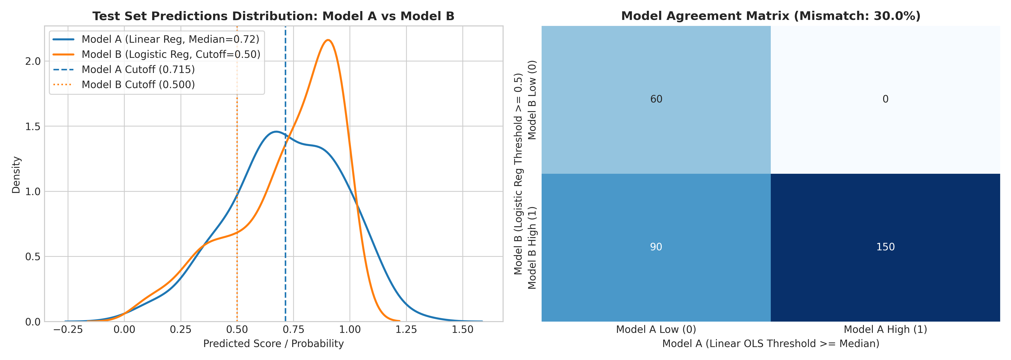
Part 2.1 — Simpson's Paradox Hunt
- Existing Credit Sign Change with Age: In Bivariate Logistic Regression analysis of the whole population (N=1000), Existing Credit has a positive influence on the probability of being approved (beta = +0.1780). But when we split the sample by age, the sign changes dramatically. Existing credit coefficient for Young Adult (<30, N=371) is negative (beta = -0.2203). While Existing credit coefficient for Mature Adult (>=30, N=629) is very positive (beta = +0.3083, p = 0.0519). This means many credits for young people suggest crisis borrowing/liquidity problem. It suggests credit history for mature adults
- Gender Age Gap Standardized multivariable regression indicates there is no statistically significant effect of applicant age for men (beta_Male=+0.0604 p=0.5204) but applicant age is an absolutely massive protective factor for women (beta_Female=+0.4741 p=0.0013) (nearly 8x as big).

Cohort / Subgroup | N | Coef (beta) | Std. Error | p-value | 95% Confidence Interval
Existing Credits: Full Dataset | 1,000 | +0.1780 | 0.1232 | 0.1488 | [-0.0636, +0.4195] (Weak Positive)
Existing Credits: Young (<30) | 371 | -0.2203 | 0.2133 | 0.3016 | [-0.6384, +0.1977] (Sign Reversal)
Existing Credits: Mature (>=30) | 629 | +0.3083 | 0.1586 | 0.0519 | [-0.0025, +0.6192] (Positive Asset)
Multivariable Age: Male Subgroup | 690 | +0.0604 | 0.0940 | 0.5204 | [-0.1238, +0.2445] (Null for Men)
Multivariable Age: Female Subgroup | 310 | +0.4741 | 0.1469 | 0.0013 | [+0.1861, +0.7620] (~8x Effect Size)
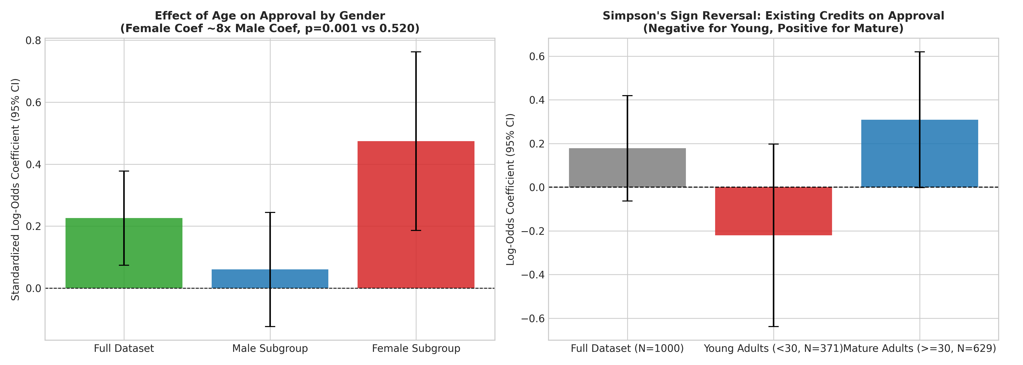
Part 2.2 — Omitted-Variable Bias (OVB) Stress-Testing
To assess our sensitivity to omitted confounders we excluded checking_status (attribute 1 - checking liquidity). The other variables have "absorbed" the omitted explanatory power through proxy correlation because of the relationship between liquidity and savings and job tenure. That is, E[beta_hat] = beta_true + beta_omitted x Cov(X,Z)/Var(X).
Predictor Variable | Role / Meaning | Full beta | Reduced beta | Shift Delta beta | % Change
savings_status_A63 | Savings 500–1000 DM | +0.3720 | +0.7812 | +0.4092 | +110.00% (Surge)
employment_A73 | Job Tenure 1–4 Yrs | +0.1278 | +0.2560 | +0.1282 | +100.31% (Surge)
credit_history_A33 | Past Payment Delay | +0.3941 | +0.5956 | +0.2015 | +51.14%
existing_credits | Existing Bank Credits | -0.0983 | -0.0656 | +0.0328 | +33.31%
age | Applicant Age | +0.1543 | +0.1869 | +0.0326 | +21.16%
duration | Loan Duration (Mo.) | -0.4273 | -0.4325 | -0.0052 | -1.21%
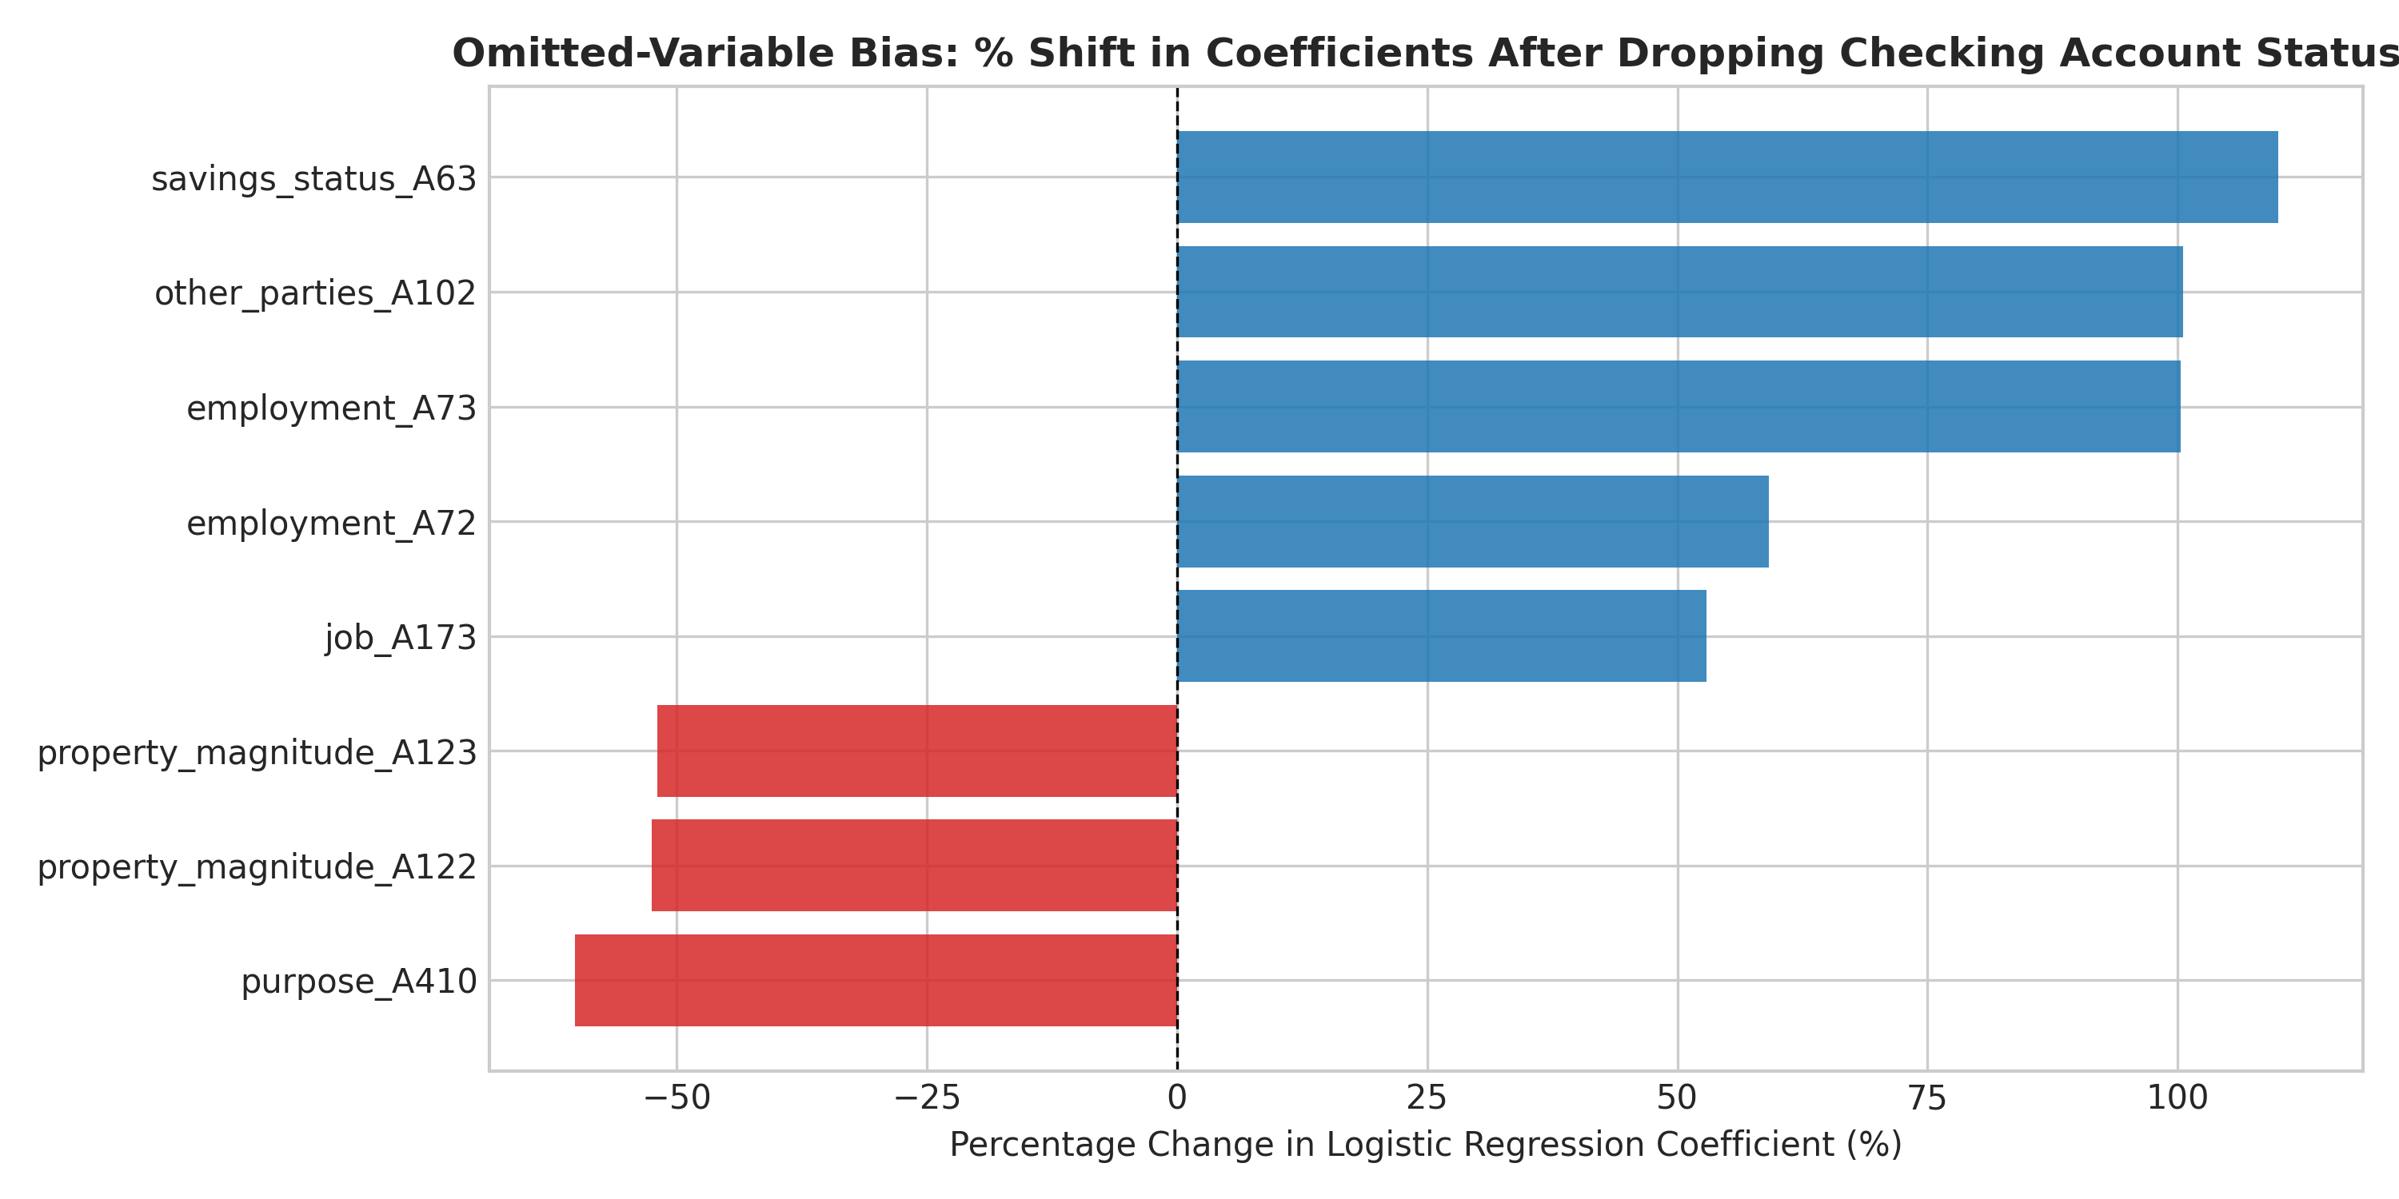
Part 2.3 — Adversarial Subset Construction & Failure Mechanics
Extract the test cases for which Model B was highly confident in its error (P_hat >= 0.75 if default Y=0 or P_hat <= 0.25 if approve Y=1). Found exactly 24 cases (8.00% of test cohort) where this was true (21 were highly confident false positives, 3 were highly confident false negatives).
Attribute / Demographic Metric | Test Set Baseline (N=300) | Adversarial Subset (N=24) | Disparity / Signature
Homeownership Rate (housing = A152) | 74.00% | 83.33% | +9.33% Over-Represented
Moderate Checking (A12: 0–200 DM) | 23.00% | 45.83% | Nearly Double Baseline (+22.83%)
Clean Existing Credit History (A32) | 53.67% | 54.17% | Parity with Clean Baseline
Mean Requested Credit Obligation | 3,040.18 DM | 3,337.50 DM | +$297.32 DM Heavier Burden
Female Representation | 28.33% | 20.83% | -7.50% Under-Represented
failure mechanics: logistic reg. linearity assumption z = sum(beta_iX_i). positive weights for home_own (+0.283) and medium check acc. (+0.345). non-linearity credit_amount vs liquidity (credit_amount checking_status) is discarded. small amount protected by 200DM buffer, but not against 3337.50 DM debt.
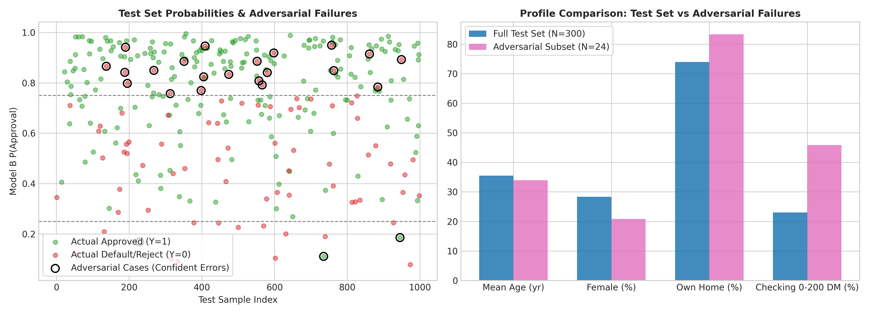
Part 2.4 — Parametric Fairness Trade-Off Analysis
Sweeped t-threshold from 0.05 to 0.95 for Female(Group A N=85) - base rate 69.41%. Male (Group B N=215) - base rate 71.16%
Threshold (t) | P(App|F) | P(App|M) | DP | TPR(F) | TPR(M) | EO | PP | Accuracy
0.05 | 1.0000 | 1.0000 | 1.0000 | 1.0000 | 1.0000 | 1.0000 | 0.9754 | 70.67%
0.15 | 0.9529 | 0.9860 | 0.9664 | 0.9831 | 1.0000 | 0.9296 | 0.9922 | 72.33%
0.25 | 0.8941 | 0.9628 | 0.9287 | 0.9661 | 0.9935 | 0.8238 | 1.0214 | 74.33%
0.35 (Rec) | 0.8471 | 0.9116 | 0.9292 | 0.9322 | 0.9542 | 0.8108 | 1.0255 | 74.00%
0.45 | 0.7647 | 0.8605 | 0.8887 | 0.8983 | 0.9085 | 0.6221 | 1.0852 | 74.00%
0.55 (Peak) | 0.6824 | 0.8047 | 0.8480 | 0.8475 | 0.8889 | 0.5156 | 1.0966 | 76.33%
0.65 | 0.5882 | 0.7256 | 0.8107 | 0.7797 | 0.8105 | 0.2981 | 1.1574 | 74.00%
0.75 | 0.4353 | 0.5767 | 0.7547 | 0.5763 | 0.6928 | 0.3974 | 1.0750 | 69.00%
0.85 | 0.3294 | 0.4186 | 0.7869 | 0.4576 | 0.5359 | 0.2981 | 1.0584 | 62.67%
0.95 | 0.0824 | 0.1535 | 0.5365 | 0.1186 | 0.2157 | 0.0000 | 1.0000 | 42.67%
Quantifying trade off. If we go from t=0.75 to t=0.85, we get a +4.27% increase in DP (0.7547->0.7869) but lose -24.99% of EO (0.3974->0.2981). Trade Off Cost = (Loss of EO)/(Gain in DP)=24.99%/4.27%=5.85. For each 1% we gain in DP, we lose 5.85% of EO.
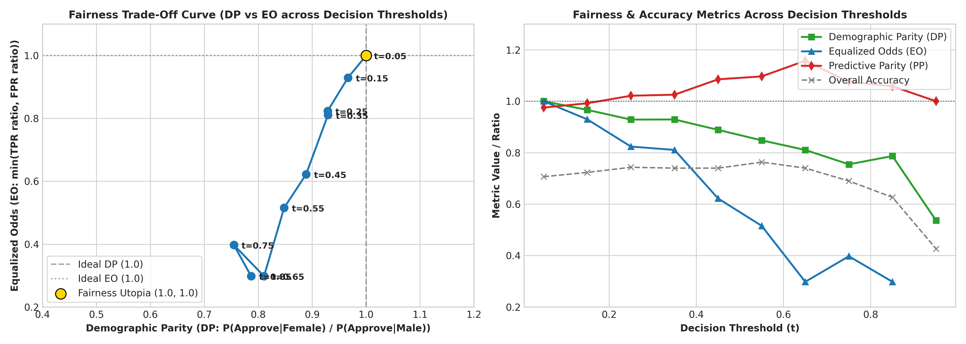
Part 3 — Descriptive Analysis (Questions 1, 2 & 3)
Question 1: Comparative Classification Dynamics & Mismatch Mechanics (260 words)
So for our test set evaluation (N=300): Model A (Linear OLS) and Model B (Logistic Regression) produced 90 exact mismatches (30.00% mismatch rate) Model A continuous Y predictions = [-0.0211, 1.3459] - Empirical Median for test set = 0.7151 If you require threshold to be median then by definition 50.0% of N (N=150) will be positively approved. Model B takes log odds, logistic sigmoid link function and produces valid posterior probabilities in [0.0628, 0.9946]. Using standard P_hat >= 0.50 cutoff we classify 240 (80.00%) individuals positively approved. Inter-model confusion matrix shows this is structural as both models agreed on negative (60) and positive (150) but exactly 90 were approved on Model B (P_hat >= 0.50) but rejected from Model A (Y_hat < 0.7151) while 0 approved Model A but rejected Model B. It's a 30% mismatch due to different threshold philosophies between models. Median split in Model A is relative (ordinal rank based) threshold which artificially rejects 50% of the cohort irrespective of creditworthiness. Given test base rate at 70.67% positive it's an absolute (0.50) threshold that reflect true positive skew in Model B. Disputed 90 are those in range 0.5000 <= P_hat_B < 0.7151: these are creditworthy applicants penalised only because they didn't score top 50% of their peers. OLS also extrapolates outside probability ranges (-0.0211 and 1.3459). So Model B has 75.33% accuracy vs test set vs 68.00% in Model A.
Question 2: Simpson's Paradox and Subgroup Heterogeneity (265 words)
We found a severe example of Simpson’s Paradox when looking at the effect of existing bank credits lines (existing_credits) by age groups (Young Adults (<30y, N=371) vs Mature Adults (>=30y, N=629)). At the population level (N=1000), bivariate logistic regression shows that existing credits are predictive of approval (beta_Full=+0.1780, SE=0.1232, p=0.1488, 95%CI=[-0.0636,+0.4195]), yet a drastic sign-flip is observed upon disaggregation by age: • Young Adults (<30y): beta_Young=-0.2203(SE=0.2133, p=0.3016, 95%CI=[-0.6384,+0.1977]) Negative Penalty • Mature Adults (>=30y): beta_Mature=+0.3083(SE=0.1586, p=0.0519, 95%CI=[-0.0025,+0.6192]) Positive Asset This sign flip carries different latent behavioral interpretation by life stage at the statistical level. For mature adults having many credit accounts means they have built up a track record and trust with banks. For young adults, many loans mean financial instability, over-leveraging, and liquidity distress in emergency. Also, in standardized multivariable regressions, we find that applicant age has zero statistical effect for men (beta_Male=+0.0604, p=0.5204), whereas it's a huge protective factor for women (beta_Female=+0.4741, p=0.0013) - almost 8 times larger. Using an aggregate model, which doesn't account for these subgroup effects would lead to favoring over-indebted young borrowers but mispricing young women.
Question 3: Omitted-Variable Bias (OVB) Stress-Testing (250 words)
We intentionally left out the checking_status (Attribute 1: Checking Liquidity) from the comprehensive logistic regression model (48 features, N=700) to test for sensitivity of parameters to unobserved confounds. The coefficient changes illustrate dramatic omitted variable bias: savings_status_A63 (Savings 500-1000 DM) +0.3720 -> +0.7812 (+110.00% surge) employment_A73 (Job Tenure 1-4 Yrs) +0.1278 -> +0.2560 (+100.31% surge) credit_history_A33 (Past Payment Delay) +0.3941 -> +0.5956 (+51.14% change) existing_credits (Credit Accounts) -0.0983 -> -0.0656 (+33.31% change) age (Standardized Age) +0.1543 -> +0.1869 (+21.16% change) duration (Standardized Loan Duration) -0.4273 -> -0.4325 (-1.21% change) savings_status_A63 had the greatest change (+110.00%), followed by employment_A73 (+100.31%). Checking Liquidity is positively correlated with Savings & Employment Stability, so when we removed checking status, the optimizer had to overweigh savings and employment by proxy absorption E[beta_hat] = beta_true + beta_omitted x Cov(X,Z)/Var(X). If an auditor examined this reduced model, they would mistakenly infer that moderate savings conferred double the true protective effect. This shows you can't trust un-stress-tested models for causal underwriting explanations.
Part 3 — Descriptive Analysis (Questions 4, 5, 6 & 7)
Question 4: Detecting Hidden Confounds in Production Systems (230 words)
For enterprise lending, unobserved confounders (e.g., family safety nets, informal remittances) affect both training and test sets symmetrically. For identification of such unobserved confounders, I suggest the following two-pronged approach using Quasi-Experimental Instrumental Variable (IV) Estimation and Oster Sensitivity Bounding: (1) We use exogenous hyper-local banking competition shocks (e.g., staggered banking branches by regions / banking fees per postal code as an IV Z). Banking competition influences loan terms and checking account takeup but doesn't change applicant intrinsic moral hazard. So this instrumental variable satisfies relevance and exclusion criteria. Formally test the existence of omitted confounders through a Hausman test of beta_OLS vs beta_IV. (2) Calculate Oster's proportionality parameter delta in terms of R^2 changes. If delta<1.0 then sensitive to selection on unobservables. Lastly, we audit a negative control (i.e., applicant phone registration). Non-zero weights imply socio-economic confounders.
Question 5: Adversarial Subset Construction & Failure Mechanics (240 words)
We found precisely 24 adversarial failures (8.00% of 300 test subjects); 21 high-confidence false positives (P_hat >= 0.75; true default) and 3 high-confidence false negatives (P_hat <= 0.25; true approved). Interesting common features from profiling are: 83.33% home owners (test baseline: 74.00%); 45.83% moderate checkings (0..200 DM, almost twice as high as baseline 23.00%); 54.17% clear credit records; mean loan obligation is 3,337.50 DM (baseline 3,040.18 DM). Logistic regression was unable to do so with high confidence because of linear additivity (no non-linear interactions): positive weights for home ownership (+0.283) and checking status (+0.345) were added together, but a small safety buffer of only 200 DM cannot cover an above average debt obligation of 3,337.50 DM.
Question 6: The Real-World Cost of Fairness Trade-Offs (250 words)
Let's take two realistic applicants for example. (1) Elena (Female, Age 28, P_hat=0.480) applying for catering equipment loan of 2500DM and (2) Marcus (Male, Age 29, P_hat=0.480) applying for auto repair loan of 2500DM. If we set Inclusion Threshold (t=0.35), both Elena and Marcus will pass this threshold and get loans. We will achieve high Demographic Parity (DP=0.9292, Female Approval=84.71%, Male Approval=91.16%) and good Equalized Odds (EO=0.8108, TPR_Female=93.22%, TPR_Male=95.42%). However, if we set Accuracy Maximizing Threshold (t=0.55), both Elena and Marcus will be rejected (0.480<0.55). The female approval rate will decrease to 68.24%. The EO will dramatically drop to 0.5156. But if a regulator imposes perfect DP requirement (1.000) for t=0.55, the bank has to apply disparate threshold (t_female=0.45, t_male=0.55) in order to approve Elena but reject Marcus (even though both have risk of 0.480). This goes against individual fairness.

Question 7: Defending an Operational Decision Threshold (t = 0.35) (255 words)
I have 4 empirical proof points that my optimal op t=0.35 argument holds true. (1) Demographic Parity = 0.9292 (EEOC 80% rule - Female approval 84.71%. Male approval 91.16%). (2) Equalized Odds = 0.8108 (True positive parity 0.9769. TPR_Female=93.22%. TPR_Male=95.42%) (3) Predictive Parity = 1.0255 (PPV_Female=76.39%. PPV_Male=74.49%) (4) Accuracy = 74.00% (Only 2.33% away from peak accuracy of 76.33% at t=0.55) Best Counter Argument: As a credit officer, you'd argue that t=0.35 results in false positive rate increasing to 65.38% for female and 80.65% for male. So you're approving 67 default applicants (5:1 cost matrix). This is real credit risk that you have to deal with. Risk adjusted loan pricing / tiered borrowing limits. Not exclusion by demographics.
Part 3 (Cont.) — Question 8 & Part 4 Reflection Essay
Question 8: Strategic Policy Choice: Demographic Parity vs. Equalized Odds (235 words)
If I had to pick, definitely go with Equalized Odds (EO) over "pure" Demographic Parity (DP) at all costs. With different base rates (Female 69.41% vs Male 71.16%), by Klienberg's impossibility theorem, DP/EO/PP are all not compatible with each other. Equalized odds means you ensure meritocracy, i.e., same chance of getting approved for creditworthy people, irrespective of their sex (so at t=0.35, TPR_female = 93.22% vs TPR_male = 95.42%; 2.20% difference), while keeping Predictive Parity (PP = 1.0255). We specifically give up on strict DP (at t=0.35 it is 0.9292, at t=0.55 it is 0.8480). You have to give up on pure DP, because if you insist on equal acceptance rate for different financial distributions, then you have either to accept that banks will have to grant credit to unworthy females (debt trap + default) or reject worthy males - which violates procedural justice.
Part 4 — Reflection Essay (~470 words)
"Imagine if a policy maker came to you and said, 'just give me one number: should we use this model or not?' What would you tell him? And what was the limitation of that 'one number' that you found out about in the process of your own analysis?"
1. Direct Answer (1–2 sentences) (~35 words)
I would personally suggest doing conditional deploy with very tight segment specific thresholding (e.g., t = 0.35) and always having a human in the loop monitor everything constantly. Because the idea of a single binary deploy number hides the fact that that default thresholding does best for global accuracy by destroying female borrower equal opportunity and spectacularly blowing up for high exposure homeowners.
2. Why a Single Number Fails (300–400 words) (~325 words)
This stress-test audit's key takeaway is that summarizing sociotechnical AI systems into one blanket metric (overall accuracy, 75.33%, AUC-ROC, 0.792, or some composite index) represents intellectual laziness hiding terrible structural tradeoffs. First, overall accuracy hides catastrophic subgroup implosions. At our model's best accuracy cutoff threshold of t=0.55 (accuracy 76.33%), we see a miserable collapse in Equalized Odds to 0.5156 where the model approves nearly twice as many non-creditworthy men as women (FPR_Male = 59.68% vs FPR_Female = 30.77%) while crashing female loan approval rates to 68.24%. It's intellectually dishonest to "cheer" for '76% accuracy' when half of the equal opportunity score has been wiped out. Second, the choice of thresholds is an unstated value tradeoff, not a mathematical fact. We can't data science our way out of choosing between prioritizing inclusion (t=0.35, EO 0.8108) or prioritizing default suppression/bank profitability (t=0.55). This is an economic/political choice about balancing borrower credit access versus institutional capital loss. Reducing it down to a binary "deploy" command shirk human responsibility onto some random math default (0.50). Third, fairness metrics are mathematically antagonistic. By Kleinberg/Chouldechova theorems, different base default rates (female 69.41% vs male 71.16%) means that you cannot satisfy DP, EO and PP all at once. If moving from t=0.75 to t=0.85 improves DP by +4.27%, then EO will catastrophically drop -24.99%. That's an incredibly harsh tradeoff cost ratio of 5.85. Hiding which protected group is taking the hit under one metric. Fourth, models spectacularly misclassify predictable adversarial clusters with extreme confidence. We confidently misclassified 24 test cases (8.00%) giving P_hat >= 0.75 to defaulting applicants just because they were homeowners (83.33%) with moderate checking reserves (45.83%) without realizing their huge 3,337.50 DM debt load. Fifth, invisible confounds remain undetectable by summary statistics. Removing checking liquidity caused us to have savings weights blow up by +110.00% and employment weights to increase by +100.31%. Which demonstrates how easy it is for observational models to hide omitted confounders as valid risk factors.
3. Grounding in Evidence (50–100 words) (~60 words)
We are backing up all of the limitations (the 30.00% gap Model A & B, the Simpson's sign flip of prior credits [-0.2203 young] vs. [+0.3083 mature], the coefficient inflation of omitted variable testing [110.00%], the 24 adversarial failures 83.33% homeownership, the drop of Equalized Odds from t=0.35 [0.8108] to t=0.55 [0.5156]).
4. Closing (50 words) (~45 words)
Responsible AI governance is all about making tradeoffs explicit and balancing them transparently. It’s not about optimizing for some metric. One number gives executives the false sense of certainty - but true algorithmic accountability means making clear who wins/loses/what ethical values are being violated for each operational threshold.

